

Notify-U

Project Category

Context-aware Application

[HPC-42117]

Mobile and Ubiquitous Computing

Group Members
- Aung Min Thant (UIT-0941)
- Chan Min Kyaw (UIT-0979)
- Chan Myae Aung (UIT-0640)
- Htet Shine (UIT-0999)
- Khant Hmue (UIT-0994)
- Sithu Kyaw (UIT-0861)
- Ye Htet Mg Mg (UIT-0963)

Document History
Date | Version |  | By | Remarks
Sep 16, 2023 | 0.01 |  | Aung Min Thant  Chan Min Kyaw  Chan Myae Aung  Htet Shine  Khant Hmue  Sithu Kyaw  Ye Htet Mg Mg | Final version

Contents at a Glance
1. Introduction 5
2. Motivation and Challenges 6
3. Architecture of the app 7
4. Minimum requirement 11
5. Implementation Details 11
6. App’s Outcomes 27
7. Conclusion 29
8. Future Plan 30
9. References 30

Table of Contents
1. Introduction 6
1.1. Mobile Computing 6
2. Motivation and Challenges 7
2.1. Motivation 7
2.2. Challenges 7
3. Architecture of the app 8
4. Minimum requirement 12
5. Implementation Details 12
5.1. Installation 12
5.2. API Implementation 15
5.2.1. API Integration with Moodle 15
5.2.2. API Implementation for Weather Information 17
5.2.3. API Implementation with Google Map 19
5.3. Backend Implementation 21
5.3.1. Models 21
5.3.2. Routes 22
5.3.3. Controllers 23
5.3.4. Auth Middleware 25
5.3.5. Validations 26
5.4. Frontend Implementation 26
5.4.1. Recoil for State Management in React 26
5.4.2. Utils Component Reducing Redundancy 27
5.4.3. Hooks for Utilizing State Management 28
5.5. Source code organization and directory structure 28
6. App’s Outcomes 28
6.1. Login/register Page 29
6.2. Home page ( Context-Based Weather Info ) 29
6.3. Class Details 30
6.4. Notification and Distance calculation 30
7. Conclusion 31
8. Future Plan 31
9. References 32

Introduction

This is all about the contextual project named “Notify-U” which is related to the subject of the mobile and ubiquitous computing. This project emphasize to notify users about their organization’s schedules, and provide location-aware weather information, and the users can also be rest assured to be notified or reminded when he/she is in the situation of potential late to the not-to-miss classes.

Mobile Computing

Mobile computing is a technology which enable anywhere/anytime connectivity and bring computer communications to areas without preexisting infrastructure, enabling mobility, new applications. It is also an exciting new research area. Mobile computing has become an integral part of our daily lives and has transformed the way we work, communicate, and entertain ourselves.

Motivation and Challenges

The following are the problems and motivation to create our Notify-U app that can solve some of the students’ difficulties.

Motivation

In an effort to keep students informed about some UIT-related information, including class schedules, crucial announcements, weather updates, important alerts, and more, our goal is to establish an information-oriented system for the organization. Furthermore, our application offers students the convenience of efficiently managing their schedules and other tasks with the help of the system. It is designed to enhance their daily routines related to UIT activities and responsibilities. We need to combine different services, keep data safe, and make sure the app works well on various devices. Finding the right balance between sending the correct information and showing accurate data can be somewhat challenging. But despite these challenges, our goal is to build an app that makes it easier for students to get relevant information, and brings convenience and our university community closer together.

Challenges

Security and Privacy: It is essential to ensure the security and privacy of sensitive student data that requires strongest security measures.
Missed important credit classes: Students will miss some important credit class unless they have awareness on the schedule in details.
Timetable Access Issue: It is uncomfortable to know the real-time class schedule by frequently using their mobile phones to open the apps like Gallery and find the timetable.
Information Accessibility: Students have to struggle to find relevant information due to it being scattered across various platforms like in mailbox or in physical noticeboard. Risks: Students may relating have safety and health risks if they don't know the real-time weather information to their current place.

Architecture of the app

Our Notify U app uses progressive web app (PWA) architecture which is compatible with all kinds of mobile devices and browsers. The following are the flowcharts of the app’s architecture.
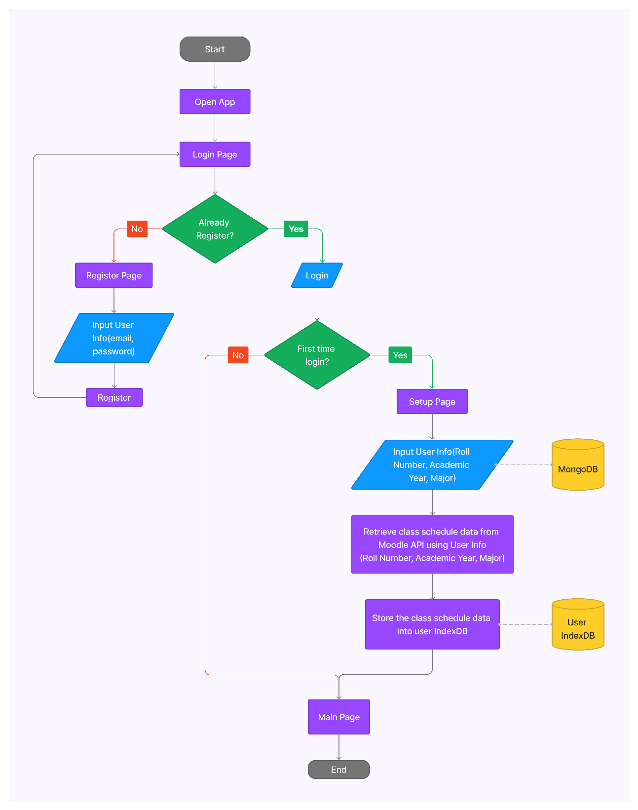
Fig. 3.1 Login Architecture
Figure 3.1 shows how login/signup system work. If the user is already register or signup to our system, one can login easily to our system. Otherwise, he will be redirected to register page. And at first login of every user, they will have to enter their information like Roll No., Major, Academic Year.
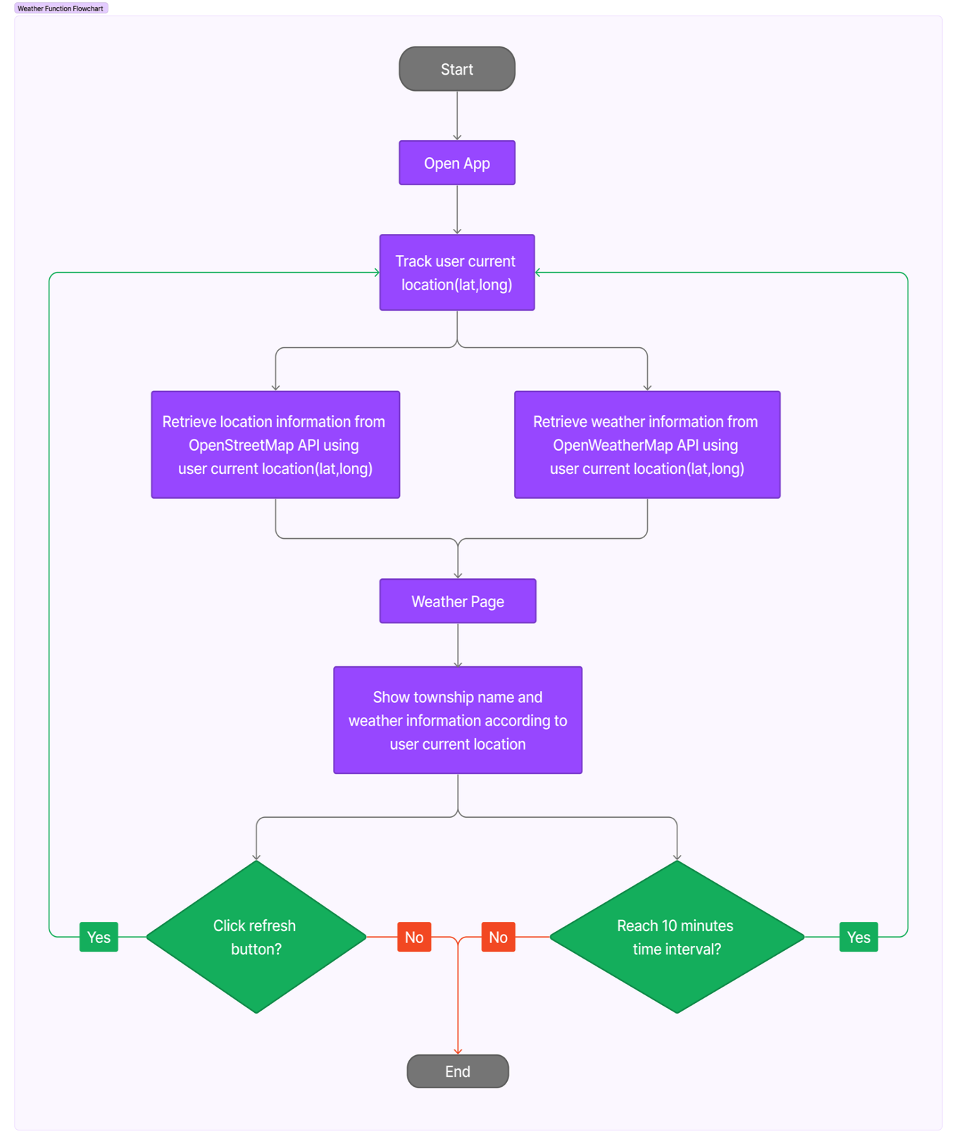
Fig. 3.2 Home Page showing weather information
Figure 3.2 visualizes in which flow the home page will work by sensing user-location related information such as latitude and longitude. After that, these info are send to and received back from APIs of OpenStreetMap and OpenWeatherMap.

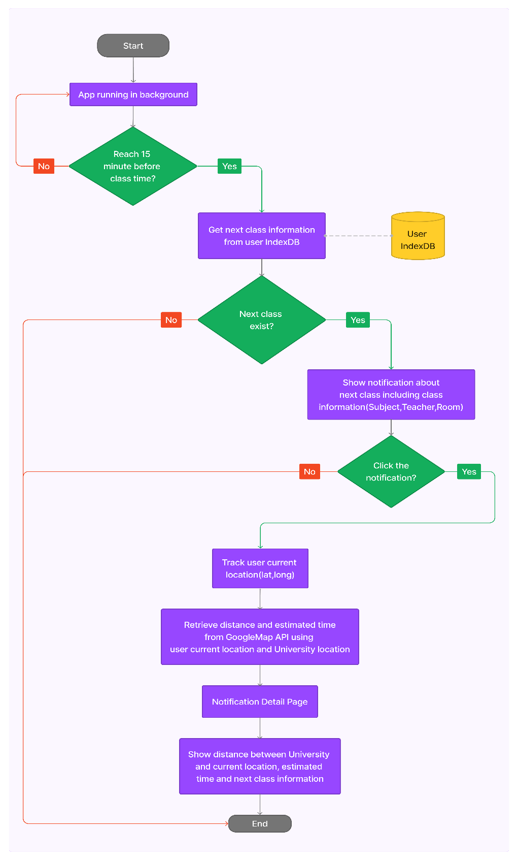
Fig. 3.3 Class notification and distance calculation
Figure 3.3 indicates which classes are upcoming and if you aren’t at university and has potentiality of missing class, the app will show you how long it will take you to go to university from where you are.

Minimum requirement

The following are details steps for implementation. The dependencies required as
There are some minimum requirements to be able to run our system. They are
1. The application requires Android Version 4.0 or higher to run.
2. It should be compatible with all types of web browsers.
3. The application must have continuous internet access.
4. The following permissions need to be granted on mobile devices:
- Location access
- Notification access for the browser
5. JavaScript must be enabled for the application to function properly.

Implementation Details

This section includes details steps for implementation of our app. These include the steps of installation process, API implementation, backend implementation and frontend implementation.

Installation

Installation process include installing MongoDB, Express.js, React and Node.js and creating a new project, installing necessary dependencies, and setting up the frontend and backend.

Step 1: Setting Up the Backend

Open your terminal and run the following command for initializing node.js project:
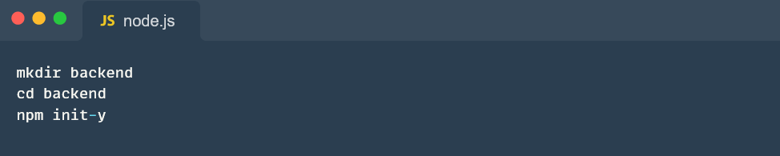

Install ‘express’ for creating the backend server and ‘mongoose’ for interacting with MongoDB:
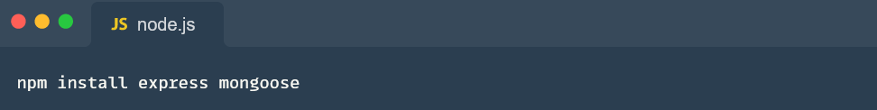

Install these backend dependencies inside ‘backend’ project:
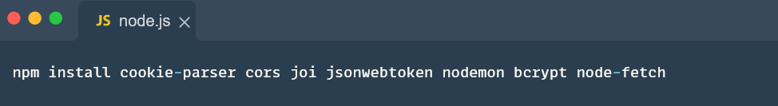
cookie-parser: This middleware helps in parsing cookies in HTTP request.
cors: This middleware allows you to control which domains are allowed to access API.
joi: Joi is a powerful schema description language and data validator for JavaScript. jsonwebtoken: This package is used to generate and verify JSON Web Tokens (JWTs).
nodemon: It will automatically restart your application so that user can see the changes in real-time.
bcrypt: It is a popular library used for securely hashing passwords.
node-fetch: It is useful for making HTTP requests to external APIs from Moodle APIs.

Step 2: Setting Up the Frontend (React)

Open your terminal and run the following command:
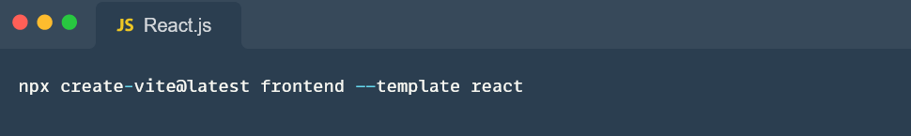

This command will create a new React app using Vite as the build tool. Navigate to your frontend project and install the Vite Tailwind plugin using npm.
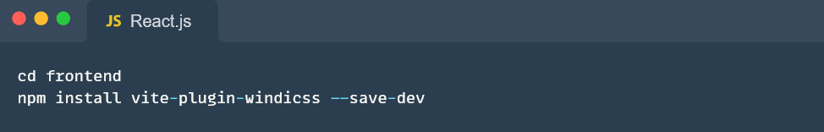

Create ‘tailwind.config.js' file in the root of frontend project and add the following content:
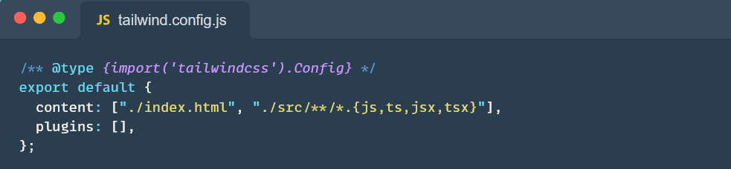

Open your ‘src/index.css’ file and add the following line at the top:
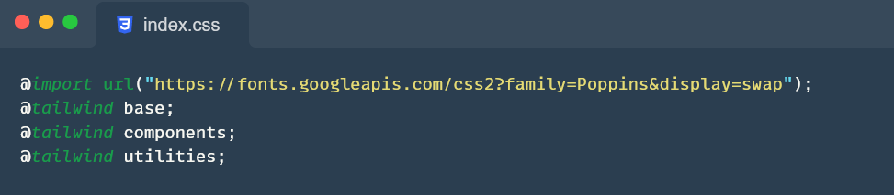
This will configure ‘tailwind.css’ to use in our react project.
Now, everything is setup according to run both frontend and backend in local development server.

API Implementation

API implementation include 3 main parts. They are API implementation with Moodle for class schedule data, API implementation with Nominatim and OpenWeather for weather information and API implementation with Google Map for distance and estimated time with user current location and university location.

API Integration with Moodle

We create our API to integrate with other LMS system. In this project, we use schedule API to get data from Moodle LMS system. Retrieve data with user controller using Moodle access key token and get data in JSON format. Then, we transform data into our required format and store in user IndexDB.
To get the most updated information about the class schedules and to make integration with other systems, our system need to get links to Moodle API with the admin access. Then, we make access key token from Moodle, creating Moodle web service to create API. According to our function needed, we created Schedule API from Moodle.

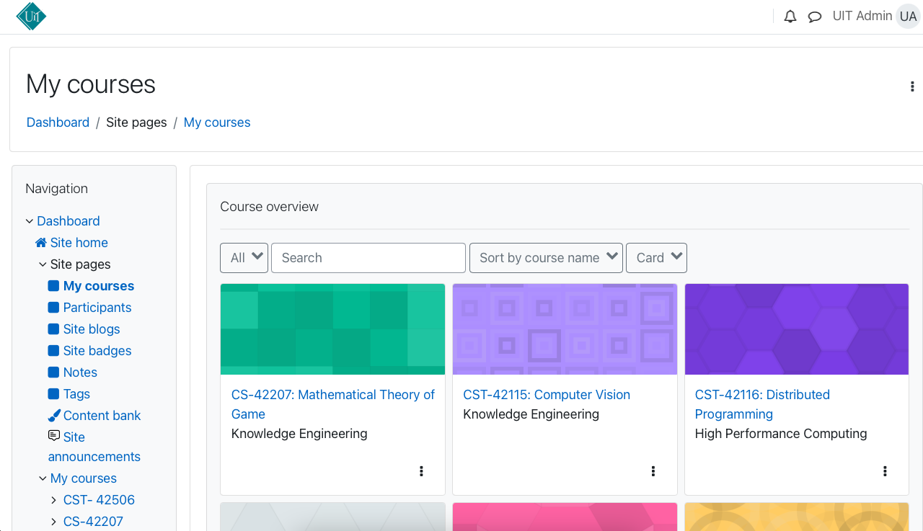

Fig. 5.2.1.1 Moodle UI (http://34.129.49.110)
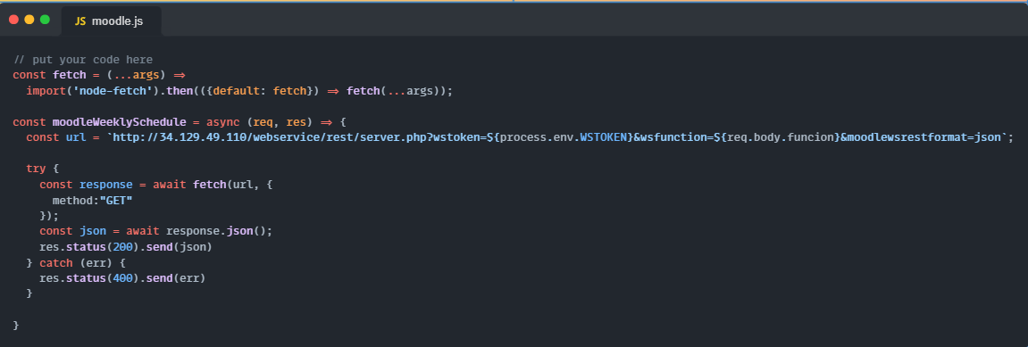

Fig. 5.2.1.2 Fetching Token from Moodle

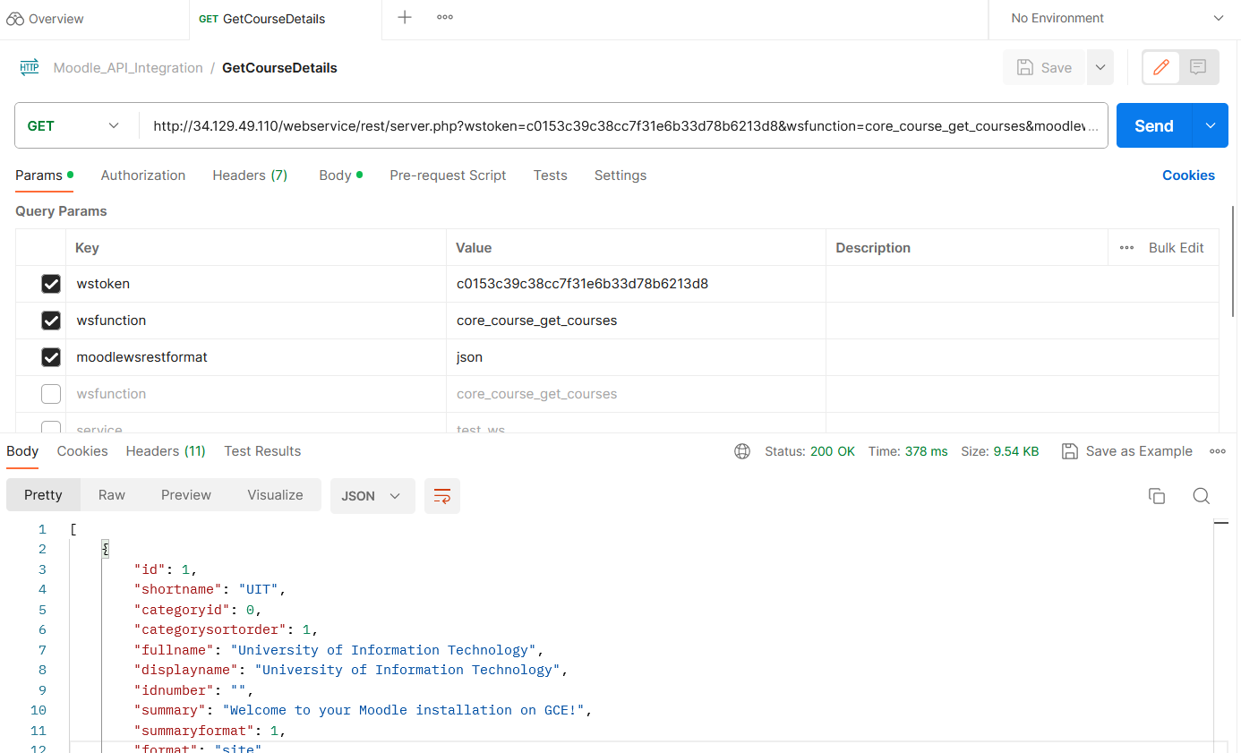Fig. 5.2.1.3 Postman on Moodle

API Implementation for Weather Information

To get location and weather information to use in our system, two APIs are used from Nominatim and OpenWeather respectively. For location information, API endpoint can be used without any prerequisite. For weather information, API access key token is created by registering an account in OpenWeather in order to use the API. Please refer to the following links for more detailed usage of APIs.
- Nominatim (https://nominatim.openstreetmap.org/ui/search.html)
- OpenWeather (https://openweathermap.org/)

Location data is retrieved by fetching Nominatim API endpoint along with the user current latitude and longitude in the endpoint.
For weather data, two OpenWeather API endpoints are used to get current weather data and hourly weather data. Both APIs are fetched along with the passing of the user current latitude and longitude as well as created API access key token in the endpoint.
All APIs are fetched in weather component and retrieved data from APIs is then used to show location and weather information in user interface. Code implementation and testing APIs on Postman are shown in following figures.

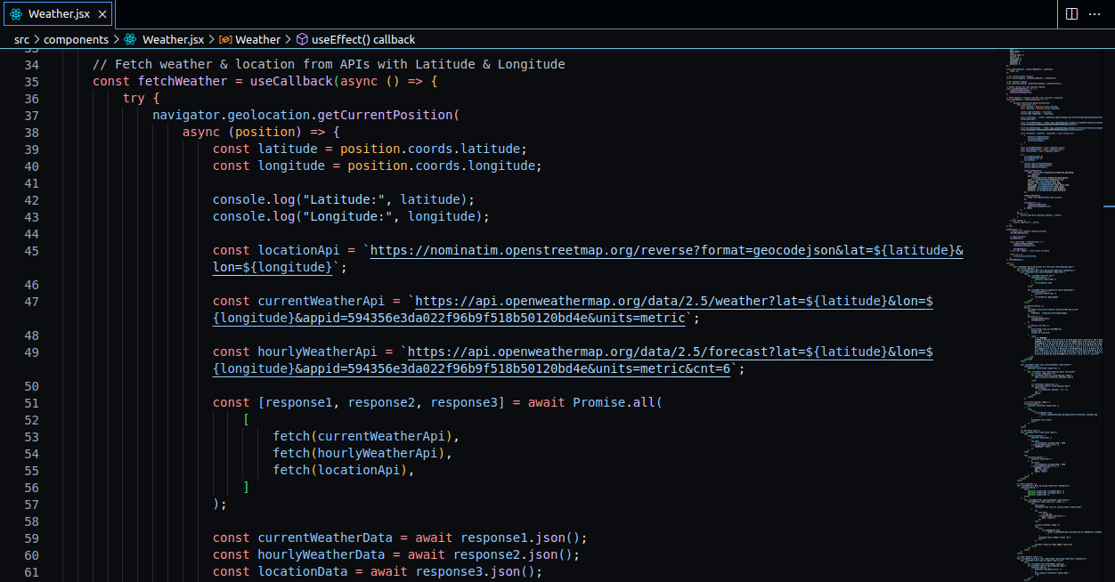
Fig. 5.2.2.1 Code Implementation of APIs
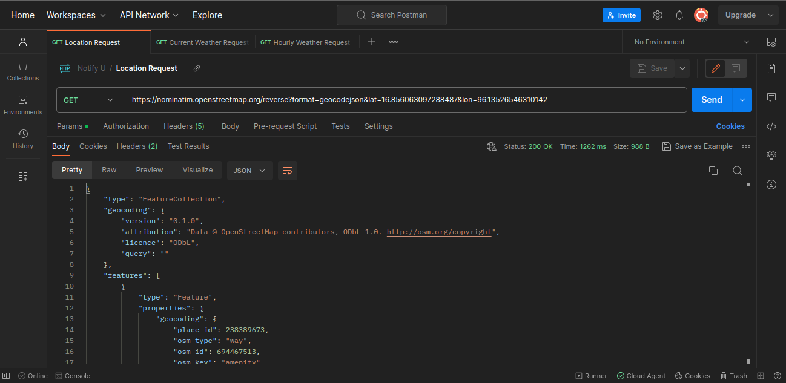
Fig. 5.2.2.2 Testing Location API on Postman

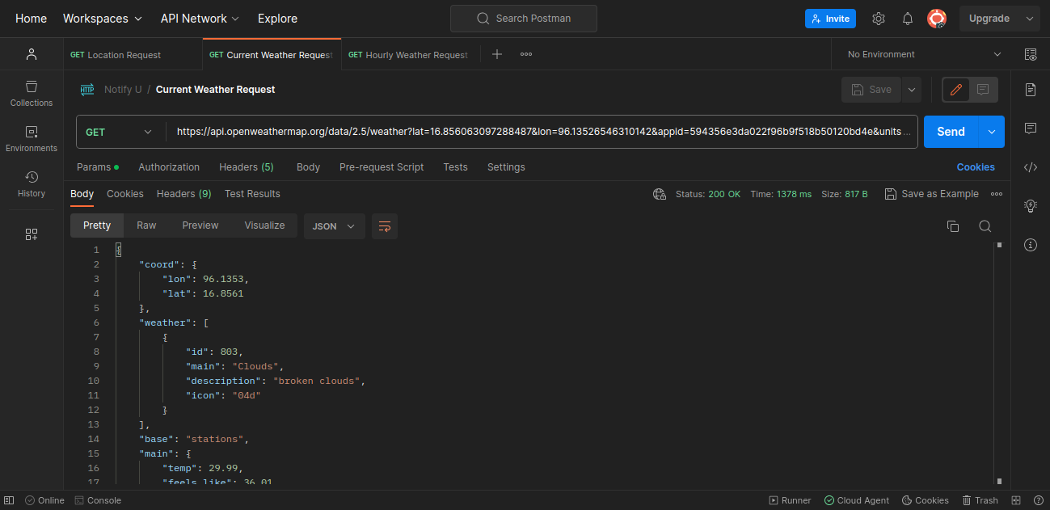
Fig. 5.2.2.3 Testing Current Weather API on Postman
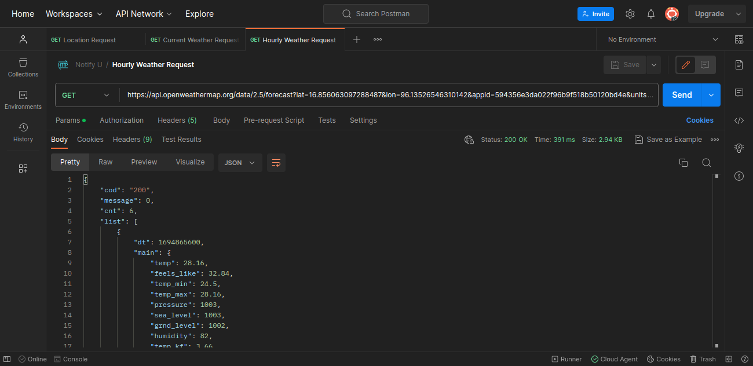
Fig. 5.2.2.4 Testing Hourly Weather API on Postman

API Implementation with Google Map

We track user current location when enter the notification detail page. Then we retrieve distance and estimated time between user current location and university location from Google Map API. The following steps are the implementation with Google Map API.

Step 1: Go to the Google Cloud Console:
Visit https://console.cloud.google.com/ and sign in with your Google Account.
Step 2: Create a New Project:
Click on the project dropdown menu and then click "New Project". Give your project a name and select a billing account (if required). Then, click "Create".
Step 3: Enable the Google Maps JavaScript API:
In the Cloud Console, navigate to the “APIs & Services” > Library” section. Search for “Google Maps Javascript API” and select it. Click “Enable”.

Step 4: Create Credentials:
In the Cloud Console, navigate to the "APIs & Services" > "Credentials" section. Click "Create Credentials" and select "API Key". Your API Key will be generated.
Step 5: Restrict the API Key (Optional):
For security reasons, it's recommended to restrict the usage of your API key.
Step 6: Use the API Key:
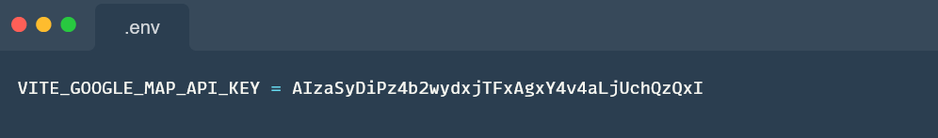Fig. 5.2.3.1 Google Map API Key
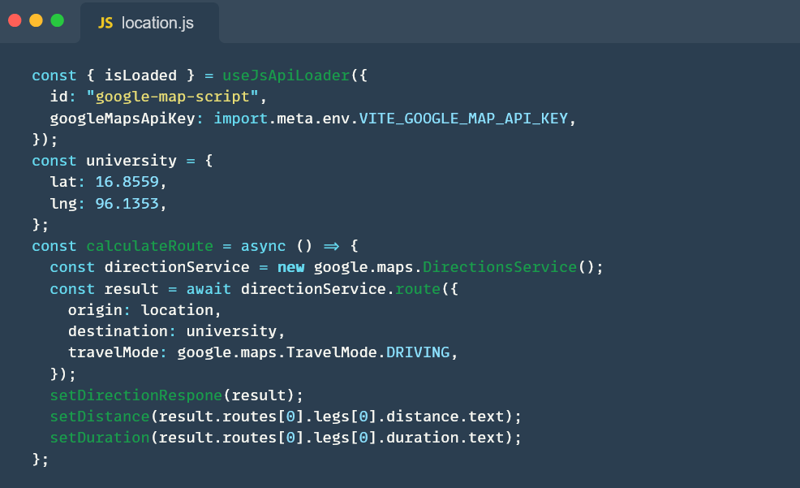Fig. 5.2.3.2 Code Implementation of API
We implement google map API in our frontend to load the location between the current user and the university and calculate the estimated distance and duration.

Backend Implementation

The backend of our project serves as the foundational engine that powers our application. It is responsible for handling data storage, processing, and retrieval. In this section, we will delve into the key components and steps involved in setting up our backend using Node.js, Express, and MongoDB.
Our backend implementation will be organized into various modules and components to ensure a clean and maintainable codebase. Here is our backend implementation structure in short form and you can check in our code source for more details.

Models
This directory will contain the data models that define the structure of our database documents.
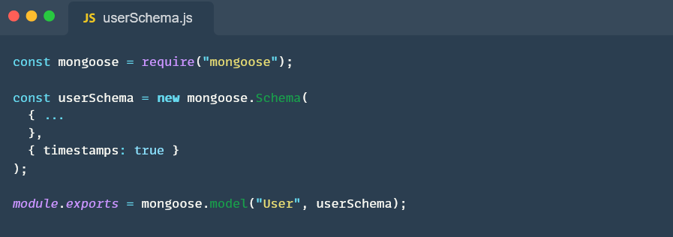Fig. 5.3.1.1 userSchema
We defined userSchema model to interact with MongoDB database in our application related with user CRUD operations.
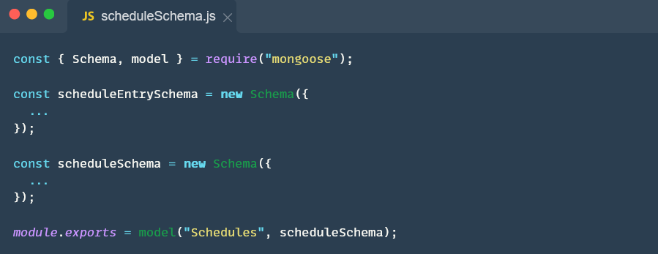Fig. 5.3.1.2 scheduleSchema
We’ve defined two Mongoose schemas for handling schedule entry, which represents a single entry in a schedule and schedule, which represents a weekly schedule for a specific year and major.

Routes
Here, we defined the API routes that handle incoming requests and interact with the database. We created two routes structures for user and schedule.
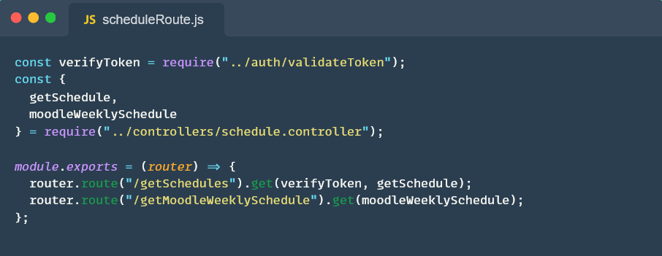Fig. 5.3.2.1 scheduleRoute
This code sets up routes for retrieving schedules and a weekly schedule from Moodle, ensuring that authentication is checked for the /getSchedules endpoint.
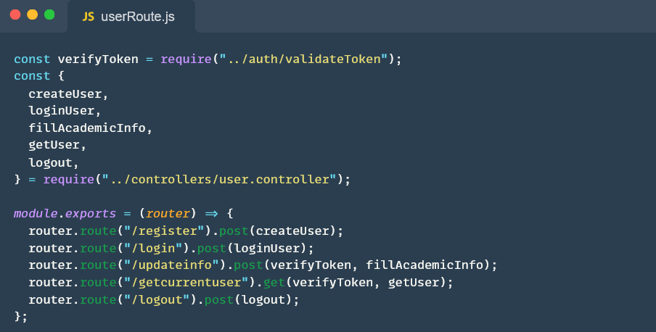Fig. 5.3.2.2 userRoute
This user route will handle user registration, login, updating academic information, retrieving the current user's information, and logging out.

Controllers
The controllers will handle the logic for processing requests, interacting with the database, and returning appropriate responses.
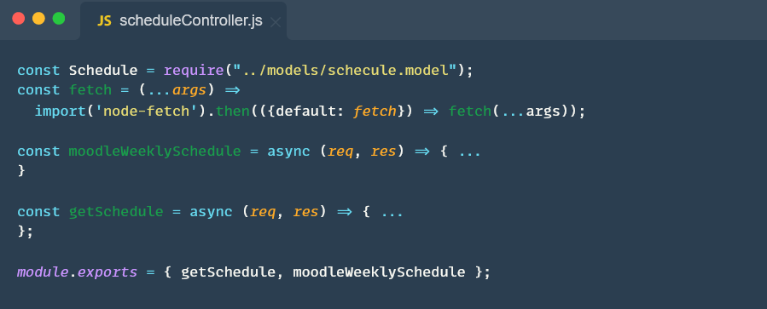Fig. 5.3.3.1 scheduleController
This schedule controller functions handle the logic for fetching schedules from both an external Moodle API and our local database based on the user's major and academic year.
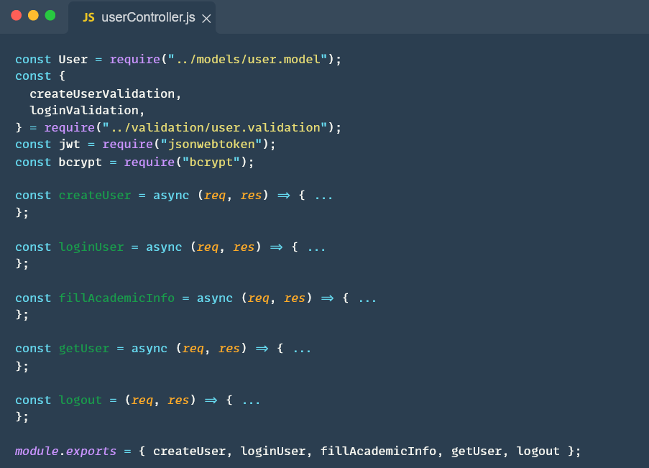Fig. 5.3.3.2 userController
These controller functions manage user registration, login, updating user information, and logout within our Node.js application and use it in routes module, providing essential user authentication and management functionality.

Auth Middleware
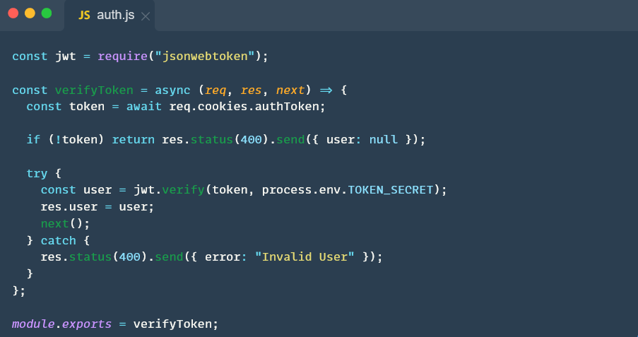Fig. 5.3.4.1 auth
Auth middleware is responsible user registration, login, and token refresh. This function handles authenticating incoming requests by checking for a valid JWT token in the request cookies.

Validations
Utility functions or modules will be stored here to handle tasks such as data validation, error handling, and more.
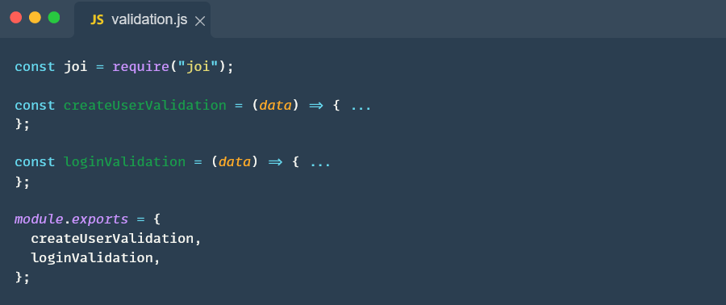Fig. 5.3.5.1 validation
These validation functions help ensure that user-provided data adheres to defined criteria before processing.

Frontend Implementation

Frontend tasks involve designing the user interface (UI) for displaying schedules, implementing user authentication for secure access, and integrating notifications for timely updates. This includes creating components, managing global state, and connecting with backend services.
In this section, we will explain the components and utilities used in the frontend. You can review the frontend design in the next section.

Recoil for State Management in React
Recoil is a state management library specifically designed for React applications. It provides a simple and efficient way to manage the state of your application and share it across different components. Here's how we utilize Recoil in our project:
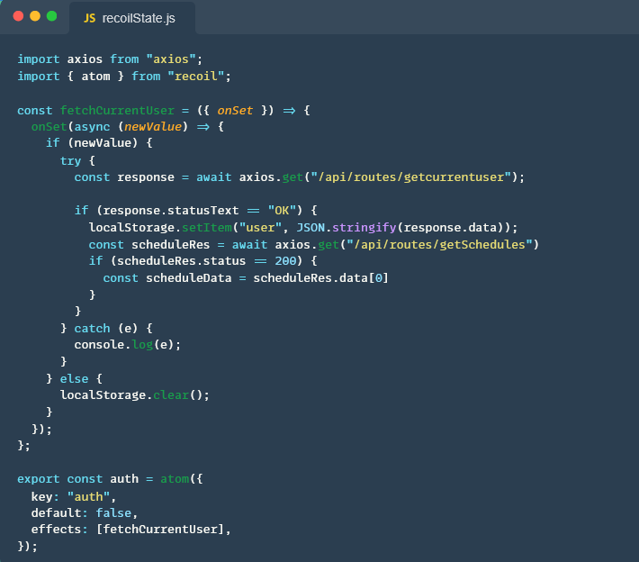Fig. 5.4.1.1 recoilState
This function represents piece of global state representing the user's authentication status. When the user logs in (newValue becomes truthy), it fetches the current user's data and schedules from the specified API routes.

Utils Component Reducing Redundancy
Utility component is a smart organizational choice that it provides a dedicated space for housing utility functions and services that can be reused across different parts of our application.

Hooks for Utilizing State Management
Our application use hooks utilities to leverage and manage state within functional components. This includes hooks like useState, useReducer, and others, which allow functional components to have the same state management capabilities as class components.

Source code organization and directory structure

Here is the code organization and directory structure of our code implementation for backend and frontend.
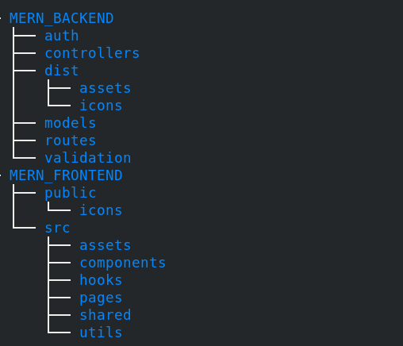
Fig. 5.5.1 Code Organization and directory structure

App’s Outcomes

This section includes our app outcomes and screenshots of real-time using.

Login/register Page
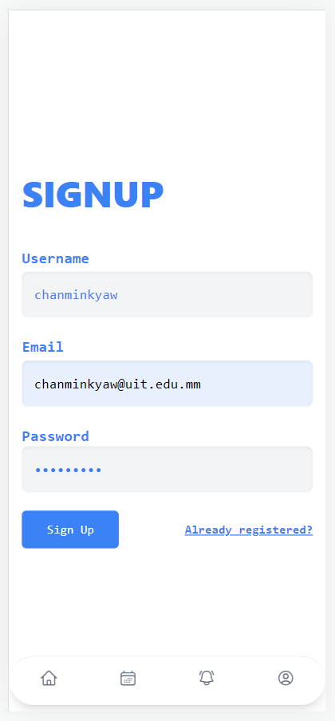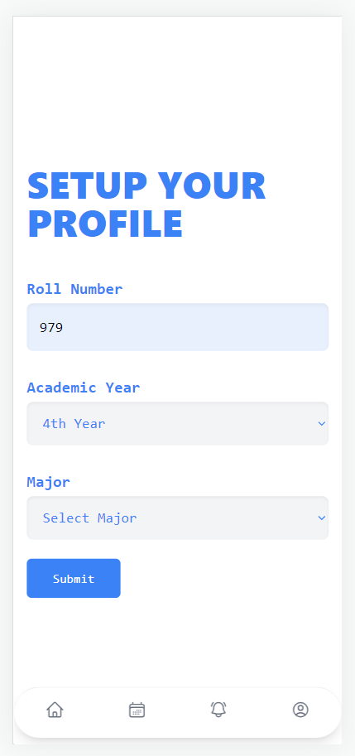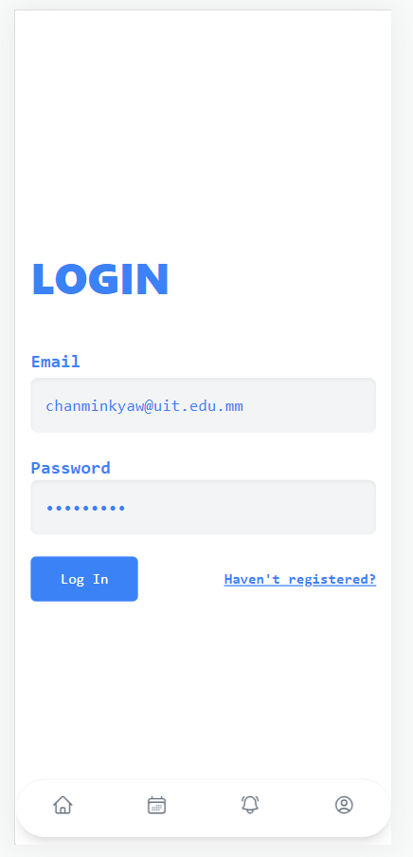

Home page ( Context-Based Weather Info )
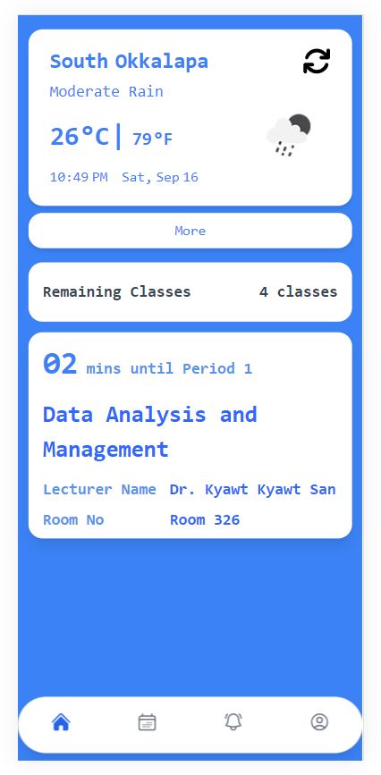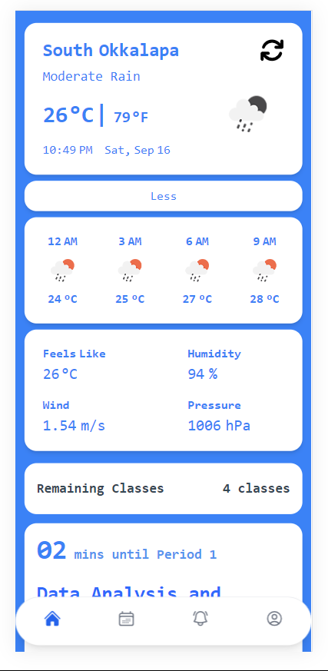

Class Details
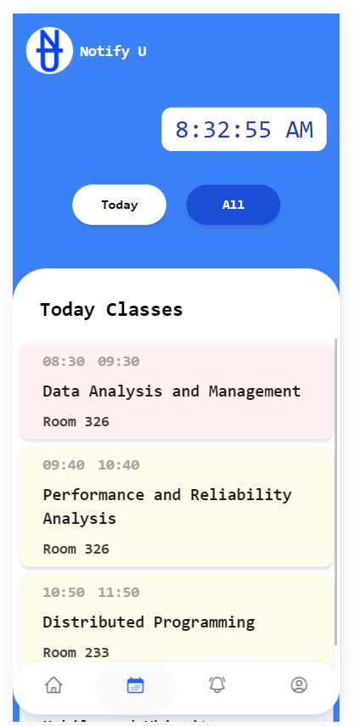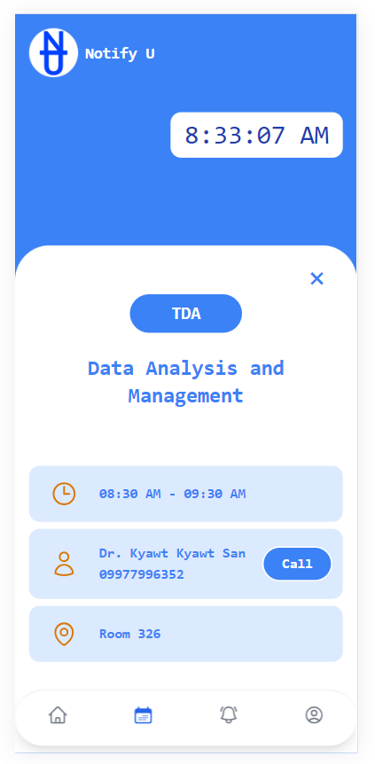

Notification and Distance calculation
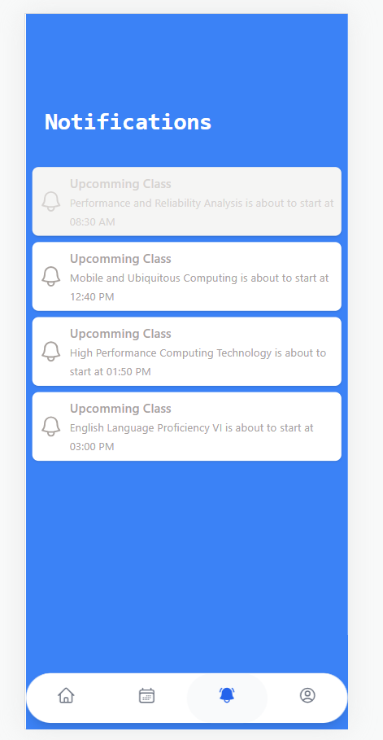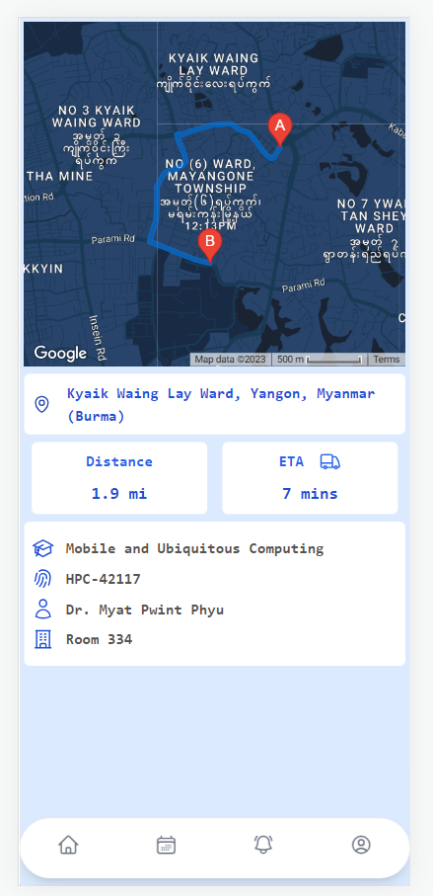

Conclusion

In conclusion, the context-aware project "Notify-U" falls within the domain of mobile and ubiquitous computing. The project's primary focus is on enhancing user experiences related to their organizational schedules and weather information. "Notify-U" aims to achieve this by notifying users of their schedules, providing location-aware weather updates, and offering timely reminders for classes to prevent potential lateness. The application calculates the estimated time of arrival by considering the user's current location, the distance to the university, and real-time traffic conditions. Additionally, class schedules are generated from Moodle API, with an emphasis on an admin user role for managing this information. Overall, "Notify-U" seeks to streamline and improve the user's daily routine through context-aware features and timely notifications.

Future Plan

First key addition is the integration of a tutorial and assignment alert feature. This enhancement will enable students to receive timely notifications about upcoming tutorials and assignment deadlines, helping them manage their academic responsibilities more efficiently. Additionally, the app will continue to be a central hub for important announcements, ensuring that all members of the university community stay informed about crucial updates and events. Furthermore, we are actively working on implementing an attendance tracking system within the app. This innovative feature will simplify attendance monitoring for both students and instructors, promoting accountability and ensuring that everyone is actively engaged in their educational journey. Our future plans for the Notify app are geared towards making it an even more indispensable tool for our university's academic and administrative needs.

References

[1] https://www.mongodb.com/docs/manual/core/document/
[2] https://expressjs.com
[3] https://nodejs.org/en/docs
[4] https://vitejs.dev/guide/
[5] https://docs.moodle.org/dev/

